Project Design Phase
Solution Architecture
Date | 28 September 2026
Team ID | SWTID-2026-5228
Project Name | Import Data using Transform Maps (Spreadsheet)
Maximum Marks | 4 Marks
Solution Architecture:
Solution architecture is a complex process – with many sub-processes – that bridges the gap between business problems and technology solutions. Its goals are to:
- Find the best tech solution to solve existing business problems.
- Describe the structure, characteristics, behavior, and other aspects of the software to project stakeholders.
- Define features, development phases, and solution requirements.
- Provide specifications according to which the solution is defined, managed, and delivered.
Solution Architecture Diagram:
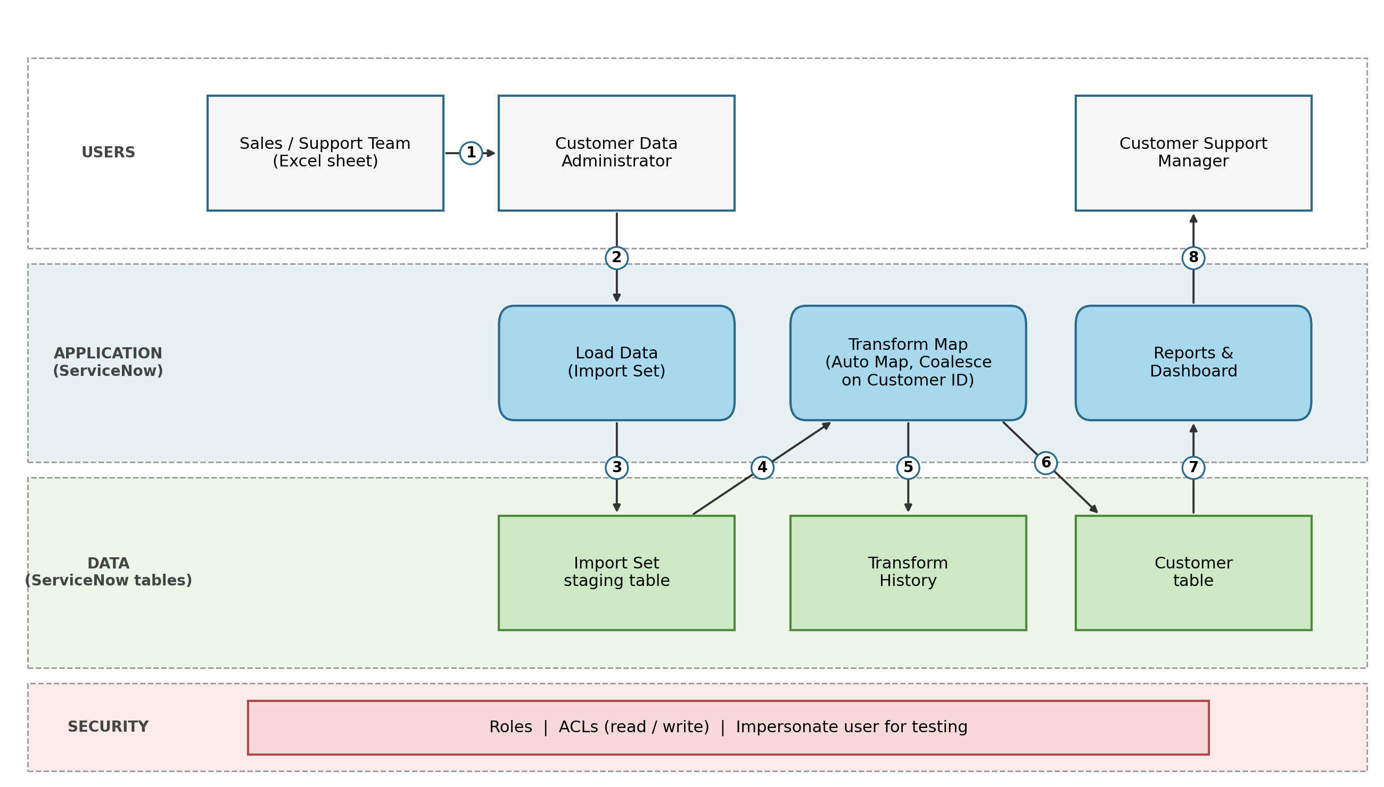
Figure 1: Architecture and data flow of importing customer data from Excel into ServiceNow using Import Sets and Transform Maps
Data flow: 1 the sales or support team sends the Excel sheet to the administrator, 2 the administrator uploads it with Load Data, 3 the rows are saved in the staging table, 4 the Transform Map reads the staged rows, 5 the transform result is logged in the Transform History, 6 inserted and updated records are stored in the customer table (Coalesce on Customer ID), 7 the reports read the customer table, 8 the support manager views the reports and dashboard. Roles and ACLs protect the data.

